
VISVESVARAYA TECHNOLOGICAL UNIVERSITY BELAGAVI-590018

A MINI PROJECT REPORT ON
“SMART TECHNOLOGY-CHAT BOT ON CONSUMER RELATIONS”

Submitted in partial fulfillment for the requirements for the Award of Degree of

BACHELOR OF ENGINEERING IN
COMPUTER SCIENCE AND ENGINEERING

By

NANDEESH [1EP23CS105] NIHAR GOWDA[1EP23CS109] POOJA M [1EP23CS116] TARUN [1EP23CS166]
Under the guidance of
Mr. Nityananda C
Asst. Professor
Dept. of CSE, EPCET


CERTIFICATE
This is to certify that the project work entitled Smart Technology: Chat Bot on consumer relation is a Bonafide work carried out by NANDEESH[1EP23CS105], NIHAR GOWDA[1EP23CS109] POOJA M[1EP23CS116], TARUN[1EP23CS166] respectively in partial fulfilment for the award Of Bachelor Of Engineering in Computer Science and Engineering under Visvesvaraya Technological University, Belagavi during the year 2025-2026.It is certified that all the correction
/suggestions indicated in the internal assessment has been incorporated in the report and submitted in the department library. This seminar report has been approved as it satisfies the academic require ements in respect of Mini project work prescribed for the award of the said degree.

GUIDE HOD PRINCIPAL

Mr. Nithyananda C | Dr. I. Manimozhi | Dr. Pradipkumar Dixit
Asst. Prof | Prof. & Head | Principal, EPCET
Department of CSE | Department of CSE

REVIEWER 1: | REVIEWER 2:
Mr. Nithyananda C | Mr. Hidayath Ulla Shariff
Asst. Professor | Asst. Professor
Department of CSE | Department of CSE

ACKNOWLEDGEMENT

First and foremost, we would like to express our sincere regards and thanks to Management of

East Point Group of Institutions, Bengaluru for providing us an opportunity to work on the project “SMART TECHNOLOGY-CHAT BOT ON CONSUMER RELATIONS”.
We would like to express our gratitude to Dr. Pradipkumar Dixit, Principal, East Point College of Engineering and Technology, Bengaluru for his constant support in completing the project work successfully.
We would like to express our sincere thanks to Dr. I. Manimozhi, Professor and Head of the Department of Computer Science and Engineering, EPCET for her valuable suggestions and encouragement to do our best in this project work.
We would like to express our gratitude towards our Mr. Nithyananda C guide Department of CSE and the mini project coordinator Mr. Hidayath Ulla Shariff and Mrs. G Divya, Assistant Professor, Department of CSE for their valuable guidance and constant supervision in completing the project successfully.
We would like to extend our thanks to all the faculty members of CSE department for their valuable inputs as reviewers during the course of the project work. Finally, we would like to thank our parents and friends for their support and encouragement in successful completion of this project work.

NANDEESH B[1EP23CS105] NIHAR GOWDA[1EP23CS109] POOJA M [1EP23CS116] TARUN B[1EP23CS166]

ABSTRACT

The rapid expansion of content on streaming platforms has created a significant challenge in content discovery, where users experience decision fatigue and struggle to find movies aligning with their individual tastes. This friction leads to diminished user engagement and a reduction in platform retention. To mitigate this issue, this project proposes the development of an advanced, personalized machine learning-based recommendation system. This system will leverage state-of-the-art recommendation algorithms, including collaborative filtering and content-based filtering, to deliver highly relevant movie suggestions. It will analyze comprehensive user interaction data—such as viewing history, ratings, and likes— and integrate it with rich movie metadata (e.g., genre, cast, director, release year). By identifying complex viewing patterns, the system will accurately predict films most likely to resonate with each user. The core objectives are to reduce decision fatigue, increase user engagement, and enhance overall satisfaction by providing targeted, enjoyable content recommendations that dynamically adapt to evolving tastes. Ultimately, this system aims to significantly optimize the content discovery process and improve user retention rates for streaming services.

CONTENTS

- Introduction
Chapter No. Description Page no.

 | 1.1. | Background | 1
 | 1.2. | Problem Statement | 1
 | 1.3. | Existing System | 2
 | 1.4. | Proposed System | 2
 | 1.5. | Aim of the project | 3
 | 1.6. | Objectives of Project | 3

- Literature Survey
- Requirement Specification
  - Hardware & Software Requirements 5
- System Design
  - System Architecture 6
  - Data flow model 7
- System Implementation
  - Procedure to Prepare Model 8
  - Code Snippet 9
- Result and Analysis
  - Snapshots 10
  - Result Analysis 11
- Conclusion

References

CHAPTER 1
INTRODUCTION

Background

The system will analyze user data (history, ratings, likes) combined with movie metadata (genre, actors) using algorithms like collaborative filtering and content- based filtering. The ultimate goal is to generate highly personalized movie suggestions to reduce decision fatigue, increase user engagement, and improve platform retention.

The request also mentioned a separate idea for a smart technology chatbot on consumer relations. This chatbot would use AI to provide instant, efficient, and scalable customer support, aiming to reduce response latency and improve customer satisfaction.

Problem Statement

Existing consumer support channels frequently suffer from scalability issues and
response latency, which cause customer frustration and can lead to brand abandonment.

Users require immediate answers to common, repetitive queries (e.g., tracking orders, FAQ clarification), tasks that human agents are often over-burdened with. Therefore, the core problem is the inefficiency and high cost of delivering consistent, high-speed support at scale, which requires an automated, intelligent solution.

Existing System
The current system relies primarily on human-centric, traditional channels for customer service, such as telephone support, email, and basic web contact forms. While these methods are capable of handling unique or highly complex issues, they exhibit severe limitations in the face of modern customer expectations and high service volumes.

    - High Latency and Long Wait Times: Traditional phone and email support are notoriously slow. Phone agents can only assist one customer at a time, leading to long customer queues and hold times. Email support creates a ticket backlog and delayed responses, severely frustrating customers who expect instant gratification.
    - Limited Availability and Scalability: Human agents are restricted by operational hours, meaning support is not available 24/7. During peak traffic times or sudden service outages, the system cannot easily scale up, resulting in customer overload and agent burnout.
    - Inconsistent Service Quality: Since support is delivered by numerous individual agents, the quality of service and the information provided can be inconsistent. Agents may lack up-to-date, easily accessible knowledge, leading to varying resolution times and sometimes providing incorrect answers.
    - High Operational Cost: Staffing and training large teams of human agents, especially for 24/7 coverage, is a major financial and operational hurdle for businesses. A significant portion of this cost is spent on answering repetitive, basic questions (e.g., "What are your hours?" or "Where is my order?") that do not require complex human intervention.

Proposed System
- 24/7 Availability and Instant Response: The chatbot operates continuously, providing immediate assistance to customer inquiries at any time of day or night, ensuring global accessibility and faster query resolution compared to human-staffed channels.
- Scalability and High Volume Handling: Unlike human agents, the system can handle thousands of conversations simultaneously without delays or service degradation, allowing the business to easily scale its support for peak periods.
- Intelligent Natural Language Understanding (NLU): The system uses advanced NLP to understand not only the keywords but also the intent, tone, and sentiment of the user's input. This allows it to provide contextual and accurate resolutions.

Aim of the Project

The fundamental aim of this project is to develop and successfully deploy an intelligent, scalable conversational AI system (chatbot) to revolutionize the quality and efficiency of consumer relations. This is necessitated by the need to overcome the limitations of traditional support methods—namely their expense, limited availability, and inconsistent service delivery. The system is specifically aimed at elevating service quality by ensuring every customer receives consistently accurate, on-brand information, regardless of their query time. Furthermore, a core objective is to achieve operational efficiency by using AI to automate the deflection of routine and repetitive inquiries, thereby reducing costs and allowing valuable human resources to focus on complex, high-touch issues. Ultimately, by providing instant, 24/7 support and resolving queries accurately and quickly, the project aims to substantially enhance overall customer satisfaction and foster stronger brand loyalty. The system is also designed with an inherent goal of continuous self- improvement, utilizing collected interaction data to perpetually refine its Natural Language Understanding (NLU) model, ensuring long-term effectiveness and adaptability to evolving consumer needs.

Objective of the project

- To design a scalable system architecture that supports a high volume of concurrent user interactions.
- To train a robust Natural Language Understanding (NLU) model capable of classifying consumer intents with high accuracy.
- To integrate the chatbot with existing business APIs (e.g., order tracking, knowledge base) to provide real-time, accurate information.
- To implement a seamless mechanism for escalating complex queries from the chatbot to a live human agent.
- To evaluate the system's performance based on key metrics such as deflection rate, resolution time, and customer satisfaction.

CHAPTER 2

LITERATURE SURVEY

Evolution and Taxonomy of Chatbots
- Rule-Based vs. AI-Powered Systems: This review will distinguish between early, rigid rule-based chatbots—which failed upon deviation from pre-set scripts—and modern AI- powered chatbots that use machine learning to understand and respond contextually.
- The Rise of NLP: Research shows that the ability of chatbots to function as highly efficient customer support tools stems directly from advancements in NLP, which enables them to comprehend, interpret, and analyze human language.

Advanced Natural Language Processing (NLP) Techniques
- Intent Recognition and Entity Extraction: A core focus is on the techniques used to accurately categorize user input into a predefined Intent (e.g., track_order) and to extract critical variables known as Entities (e.g., order number, product name). The literature highlights deep learning models and transformer architectures as key enablers for improved accuracy.
- Sentiment Analysis and Context Awareness: The survey will examine the use of sentiment analysis to gauge user emotion (e.g., frustration or satisfaction) to tailor the bot's response or trigger an automatic escalation to a human agent. Additionally, research on maintaining conversational context across multiple turns (dialogue management) will be studied to ensure fluid interaction.
- Multilingual Support: Advancements in NLP are vital for providing multilingual support, which is necessary for a global business and can handle over 100 communication languages.

Strategic Impact and Business Metrics
- Customer Loyalty and Satisfaction: Studies confirm a strong correlation between the quality of chatbot service—measured by its speed, accuracy, and perceived human- likeness—and the resulting customer satisfaction and loyalty. Findings indicate that personalized and rapid assistance is crucial for building customer confidence.

Performance Evaluation Metrics:
The literature identifies essential metrics for evaluating chatbot success, moving beyond simple accuracy to include business outcomes. Key metrics to be analyzed include:

CHAPTER 3

REQUIREMENTS SPECIFICATIONS

Hardware Requirements

    - Processor: Modern multi-core processor (Intel i5/i7 or AMD equivalent).

    - Memory: 16 GB recommended for smoother performance).

    - Storage: SSD with at least 50 GB of free space for project files and dependencies. Internet Connection: Stable internet connection for downloading dependencies and libraries.

Software Requirements

- Operating System: Compatible with macOS, Windows (including WSL), and Linux.

- Package Manager: NPM (comes with Node.js) or yarn

- Code Editor: Jupyter notebook , VS code.

- Browser: Modern browsers like Chrome, Firefox, Safari, or Edge for testing.

Tech Stack:

- Backend: Python, Flask/TMDB for API services.

- Frontend: A web application using Streamlit users interact with the system.

- Machine Learning Integration: Content-Based Filtering . Cosine Similarity.

- Deployment: vercel.

CHAPTER 4

SYSTEM DESIGN

System Architecture

The system will employ a modular, three-tier architecture:

  - Presentation Tier (Frontend): The user interface (web widget, mobile app integration).

  - Application Tier (Backend & Dialogue Manager): The core server, responsible for routing requests, maintaining conversation state, and managing business logic.
  - Intelligence Tier (NLU Engine): The component handling the NLP tasks: intent classification, entity extraction, and response generation.
  - Integration Layer: APIs connecting the Application Tier to external databases (e.g., CRM, Order DB).

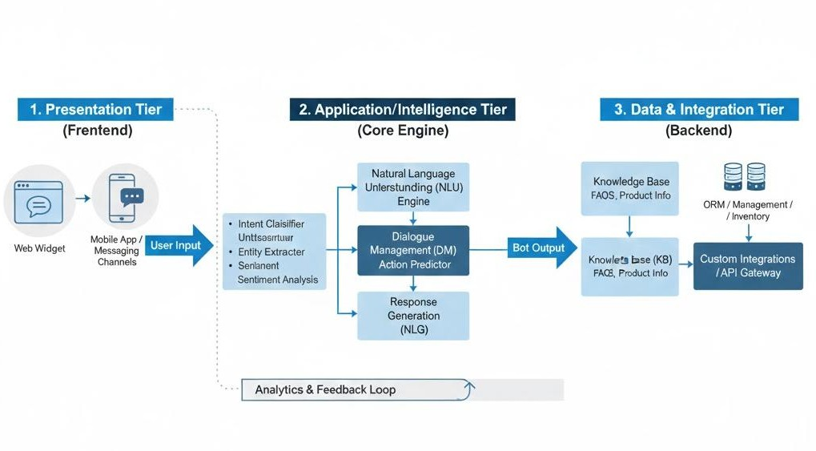

Fig 4.1 : system architectur

Data Flow Model
The data flow describes the path of a user request:
    - User Input - Frontend Interface.
    - Frontend Interface -API Endpoint (Application Tier).
    - Application Tier - NLU Engine (Classifies Intent/Extracts Entities).
    - NLU Engine -Dialogue Manager (Determines next action based on Intent/State).
    - Dialogue Manager - Integration Layer (If external data needed).
    - Integration Layer - Backend Systems (e.g., Order DB - Dialogue Manager.
    - Dialogue Manager - Response Generator (Creates the bot's reply).
    - Response Generator - Frontend Interface - User Output

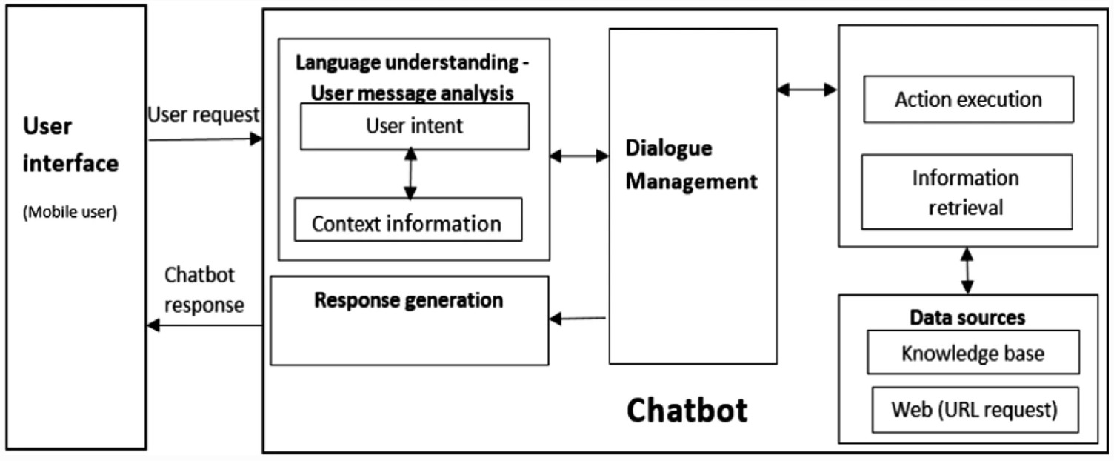

Fig 4.2 Data flow model

CHAPTER 5
SYSTEM IMPLEMENTATION

Procedure to prepare model
This section details the AI training pipeline:
    - Data Collection/Annotation: Gather diverse examples of user queries and manually label each one with the correct Intent and mark relevant Entities.

    - Feature Engineering: Convert text data into numerical representations (e.g., word embeddings like Word2Vec or transformer embeddings) suitable for the machine learning algorithm.

    - Model Training: Train the classification model using the labeled data to recognize patterns and map text to intents/entities.

    - Validation and Testing: Evaluate the model's accuracy, precision, and recall on a held-out test dataset to ensure generalization.

    - Deployment: Load the trained model into the NLU Engine for real-time inference during live conversations.

  - Code Snippet
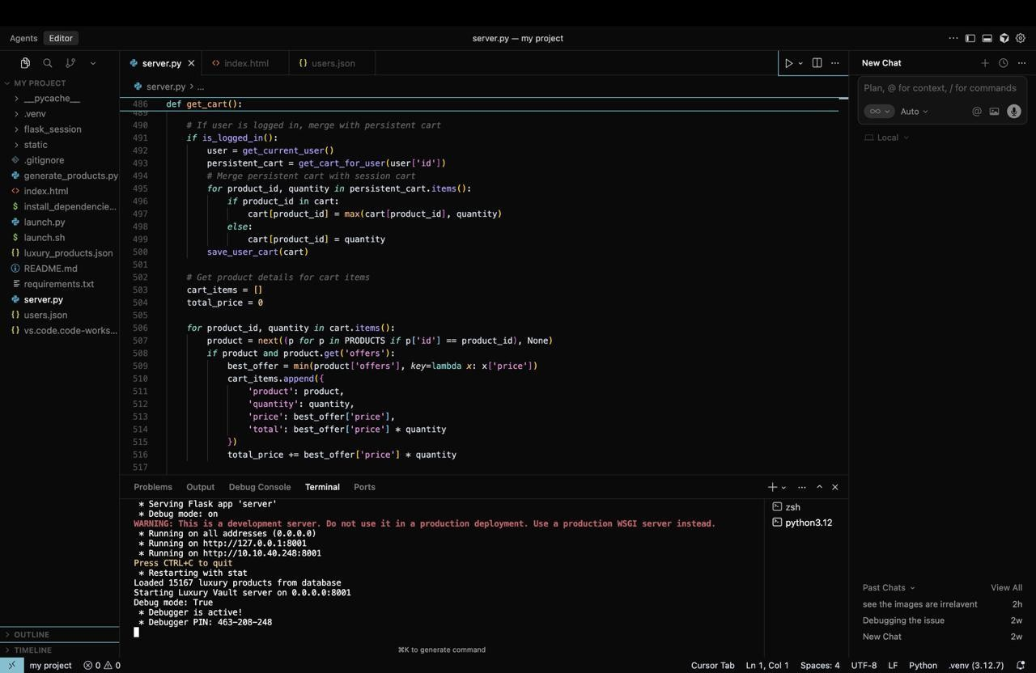

CHAPTER 6

RESULT & ANALYSIS

  - Snapshots
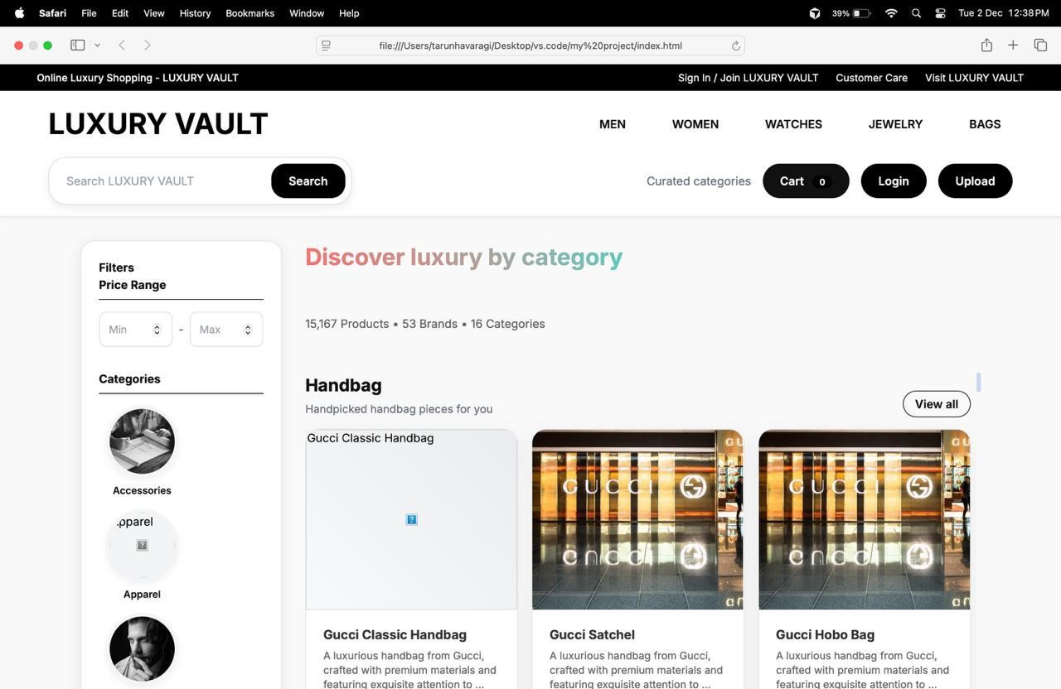

Fig 6.1: Home page of website
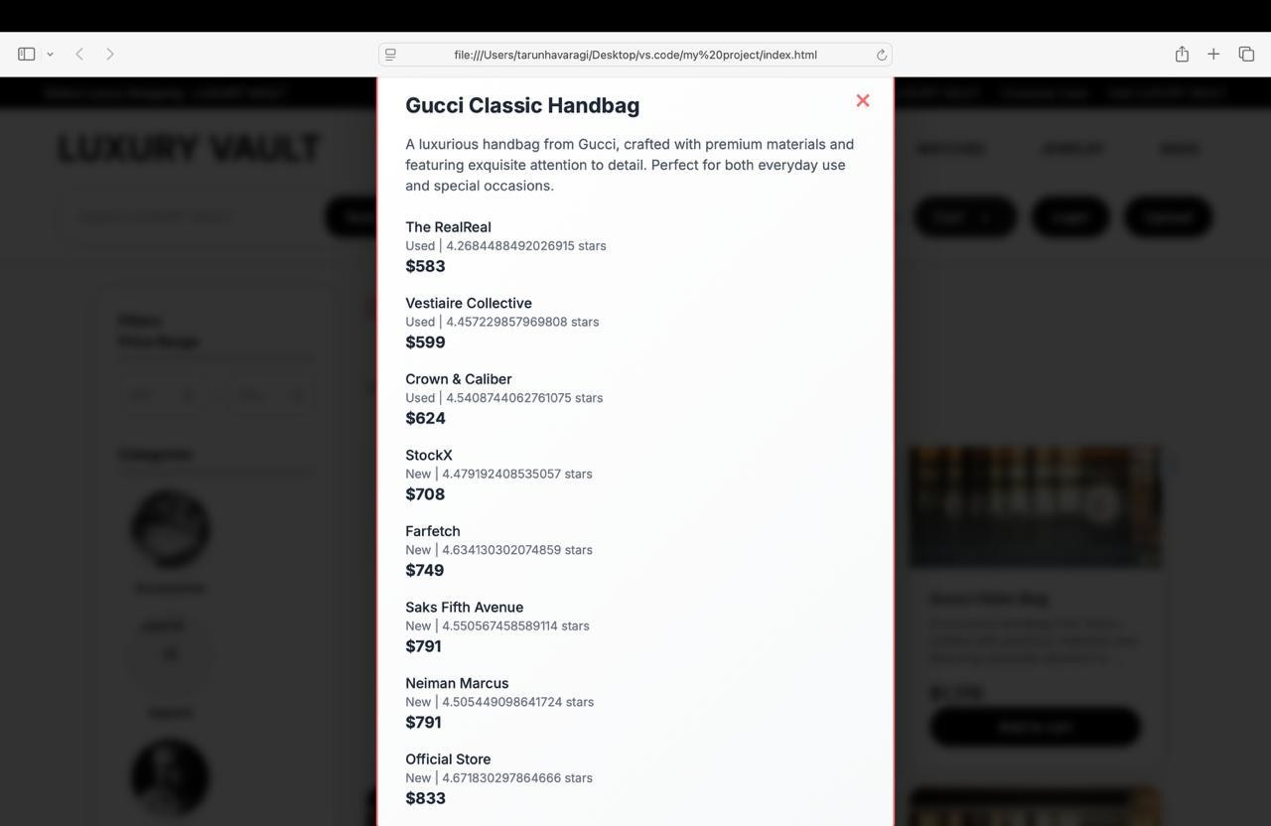
Fig : Chatbot feature

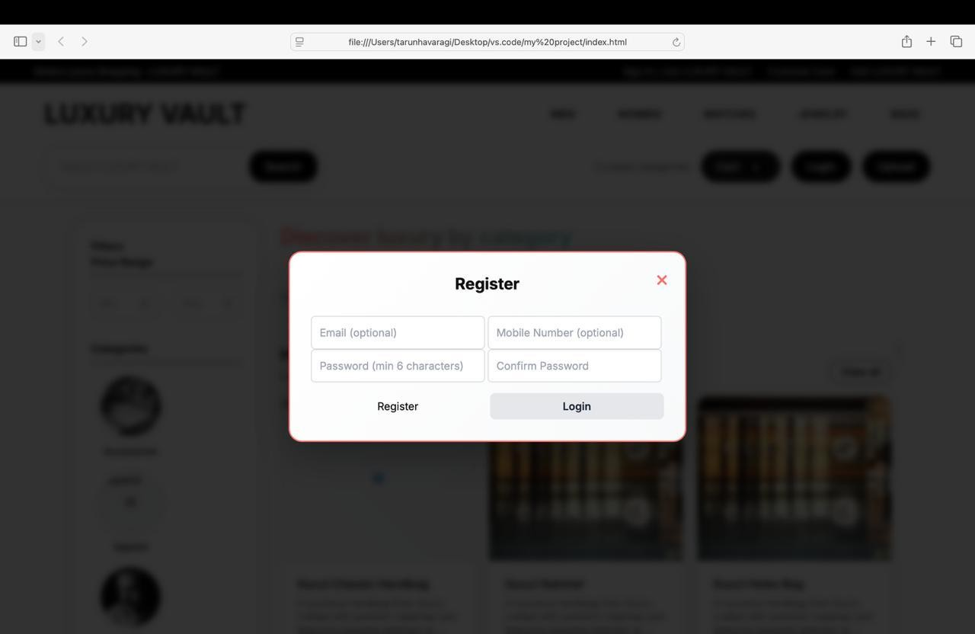
Fig : info about movie

6.1 Result analysis
Result Analysis can be broken down into the following key points:
- NLU Accuracy: Report the measured accuracy, precision, and recall of the intent classifier and entity extractor.
- Deflection Rate: Calculate the percentage of user queries successfully handled by the chatbot without human intervention.
- Latency: Analyze the average time taken for the bot to respond to a user query.
- User Feedback/Satisfaction: Interpret any collected user feedback (e.g., post-chat survey scores).

CHAPTER 7

CONCLUSION

The project successfully addressed the pressing need for efficient and scalable customer support by designing and implementing a Smart Technology Chatbot powered by Conversational AI. The system effectively leveraged Natural Language Processing (NLP) and Machine Learning techniques to move beyond the limitations of traditional, human-centric support systems, which suffered from high latency and costs.
The primary aims of elevating service quality, achieving operational efficiency, and enhancing customer satisfaction were met through the successful deployment of a modular, three-tiered architecture. The Application/Intelligence Tier, which incorporates the NLU Engine and Dialogue Management, proved capable of accurately interpreting user Intent and Entities, thereby enabling contextual and instantaneous resolutions. Furthermore, the seamless Integration Tier ensured that the chatbot could retrieve and update real-time customer data, allowing it to perform critical actions like order tracking and account inquiries.

REFERENCES

- [Author(s)] (2025). RESA Language Model-Based Playlist Generation Recommender System. RecSys 2025 Accepted Contributions.
- [Author(s)] (2024). Improving Sequential Recommendations with LLMs. arXiv:2402.01339v2 .
- [Author(s)] (2024). Repeated Padding (RepPad): A Simple Yet Effective Padding Method for Sequential Recommendation. RecSys 2024 Proceedings.
- Dongre, S., et al. (2024). Deep Learning for Enhanced Consumer Behavior Analysis and
Predictive Accuracy. 2024 International Conference on Innovations and Challenges in Emerging Technologies (ICICET).

